f(x) = 2x
f(x) = 2^{x}
f(x) = x²
f(x) = log₂x
f(x) = x+2
the power of 2 that makes the result equal the input
input plus 2 input times 2 input squared 2 times itself input times
x
2 to the power of the input

1 |  | 3 |  | 2 |  | 1 |  | 2 |  | 0
2 |  | 4 |  | 4 |  | 4 |  | 4 |  | 1
3 |  | 5 |  | 6 |  | 9 |  | 8 |  | 1.584962501
4 |  | 6 |  | 8 |  | 16 |  | 16 |  | 2
5 |  | 7 |  | 10 |  | 25 |  | 32 |  | 2.321928095
6 |  | 8 |  | 12 |  | 36 |  | 64 |  | 2.584962501
7 |  | 9 |  | 14 |  | 49 |  | 128 |  | 2.807354922
8 |  | 10 |  | 16 |  | 64 |  | 256 |  | 3
9 |  | 11 |  | 18 |  | 81 |  | 512 |  | 3.169925001
10 |  | 12 |  | 20 |  | 100 |  | 1024 |  | 3.321928095
11 |  | 13 |  | 22 |  | 121 |  | 2048 |  | 3.459431619
12 |  | 14 |  | 24 |  | 144 |  | 4096 |  | 3.584962501
13 |  | 15 |  | 26 |  | 169 |  | 8192 |  | 3.700439718
14 |  | 16 |  | 28 |  | 196 |  | 16384 |  | 3.807354922
15 |  | 17 |  | 30 |  | 225 |  | 32768 |  | 3.906890596
16 |  | 18 |  | 32 |  | 256 |  | 65536 |  | 4

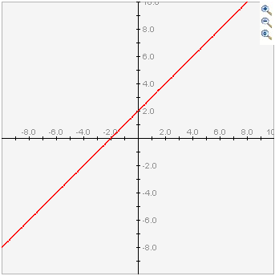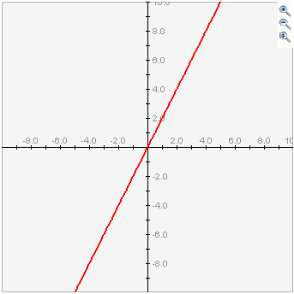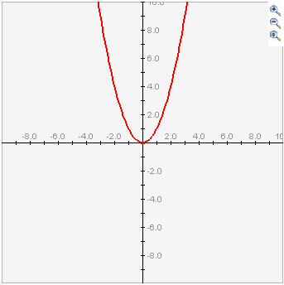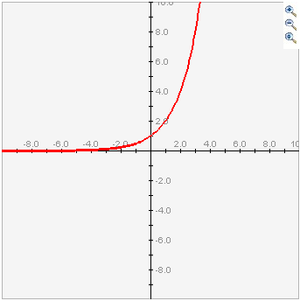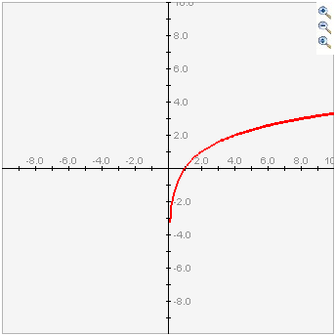
input You say, “12” You say, “12” You say, “12” You say, “12” You say, “12”

output I say, “14” I say, “24” I say, “144” I say, “4096” I say, “Between 3 and 4”
The output is too hard to picture— like the 12th dimension.
Also too hard to picture—like the inverse of the 12th dimension.
input

output

12 + 2 12 • 2 12 • 12 2 ¹² 2 ^{3.584962501}

