Geoboard Area

Each one of these has an area of 12 square units. Perimeters vary (natch).
Try this online at http://nlvm.usu.edu/en/nav/frames_asid_277_g_1_t_3.html?open=activities

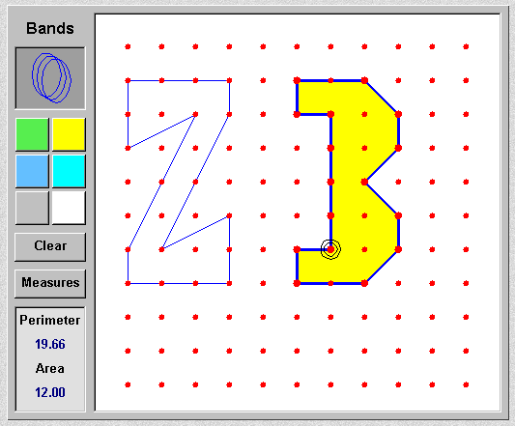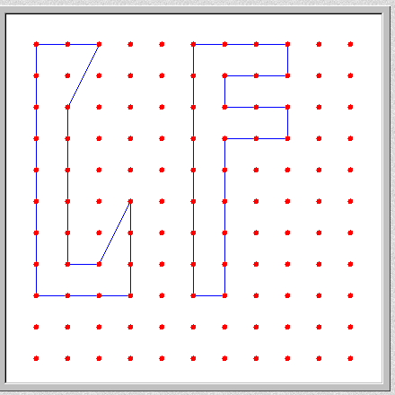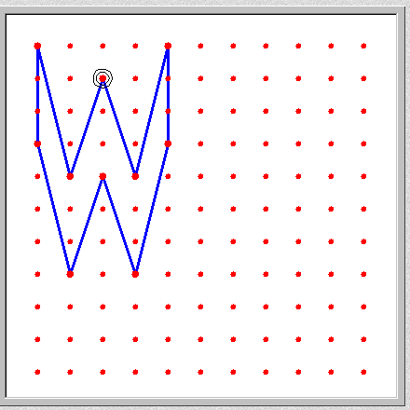

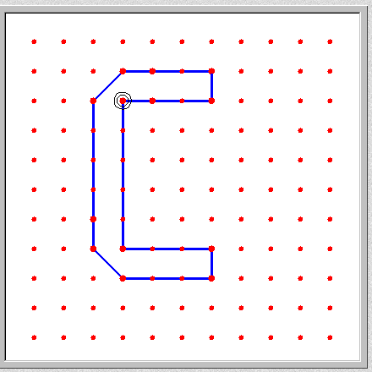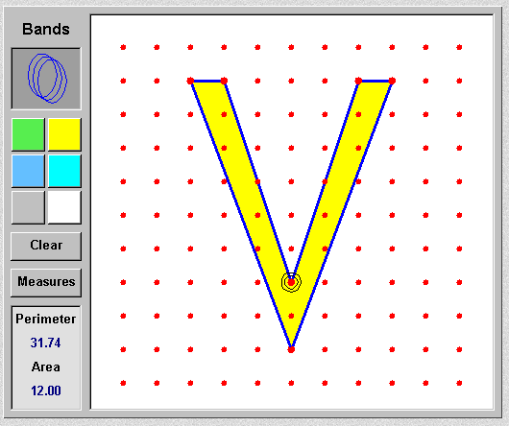
make your own initials
with areas = 12 square units

