SAT, ACT, or PSAT Practice Exams on LearningExpress Library
This resource is available to all K12 students and educators in Oregon. To create an account, follow these steps:
- Go to: www.oslis.org
- Click on Elementary or Secondary Student
- Click on Find Information
- Click on the Learning Express logo
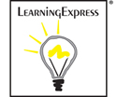
- At the Home page
Click on Register (Top right corner)
- Fill out the short form and click on Create Account.
  - The email address you enter will become your username.
  - You will be prompted to choose your own password.
  - Record this information in a safe place so you can access it when needed each time you log in.
LearningExpress Library helps students and adult learners improve the skills required for academic and career success. There are practice sets and tutorials to develop skills in math, reading, writing, and basic sciences. Also, there are practice tests to help prepare for taking the GED, SAT, ACT, AP, PSAT/NMSQT, career certification tests such as NCLEX-RN, Praxis I and II, and more. Popular software tutorials and basic computer instruction are also included.
Once you are logged into LEL…
- Scroll through the choices to College Prep Center, click on it.
- Click on Prepare for ___ (select the exam from the choices)
- You will see the SAT Practice Test link on the left side of the page.
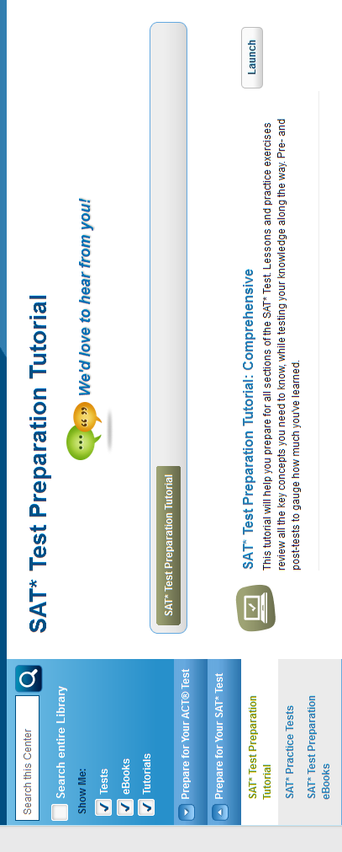

Note that there are also exam prep eBooks available, in the blue area at the left side of the page.
Gale remote access (from home):
Username:
Password: oslis

