Pi Day: 3.14…
The Exploratorium's 2010 - 22nd Annual Pi Day Celebration
http://www.exploratorium.edu/pi/index.html
NPR: “Pi Day Celebrates a Mysterious Number”
http://www.npr.org/templates/story/story.php?storyId=88226443
NPR: “Pi Day: An Infinite Number of Ways to Celebrate”
http://www.npr.org/templates/story/story.php?storyId=88239845
lower on the page is “Happy Pi Day from the Pi Guy”
Wikipedia: Pi and Albert Einstein
http://en.wikipedia.org/wiki/Pi

Wikipedia has a great animation called “Pi-unrolled” (shown above). You can see a large version of it at http://en.wikipedia.org/wiki/Image:Pi-unrolled-720.gif
Albert Einstein was born March 14, 1879. There’s a lot of info about him at http://en.wikipedia.org/wiki/Albert_Einstein and even more at http://www-groups.dcs.st-and.ac.uk/~history/Mathematicians/Einstein.html including the essay “Geometry and Experience”
"Pi, Pi, Mathematical Pi" (to the music of “Bye, Bye Miss American Pie”)
http://www.stevetoner.com/ph/TonerS/mathpi.html (The authors’ personal pages are at http://www.alltooflat.com/about/personal/ton/ and http://www.stevetoner.com/
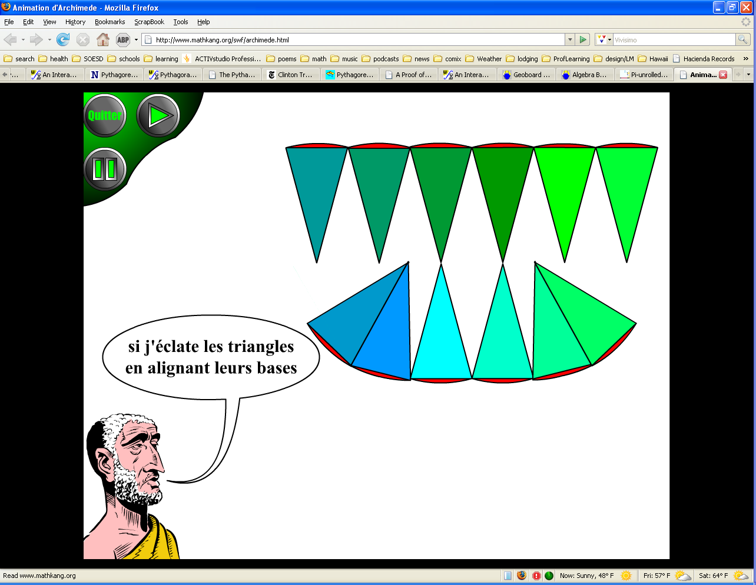
A history of Pi (Pi Through the Ages)
http://www-history.mcs.st-and.ac.uk/history/HistTopics/Pi_through_the_ages.html
Talking about Pi
http://www.cecm.sfu.ca/~jborwein/pi_cover.html
Archimedes' proof for the area of a circle
Here's a very nice flash illustration—with audio in French
http://www.mathkang.org/swf/archimede.html
Here’s a couple in English from Tom Richmond:
http://www.wku.edu/~tom.richmond/circle1.html
and http://www.wku.edu/~tom.richmond/circle2.html
You can also find them at the National Curve Bank:
http://curvebank.calstatela.edu
pages from the math forum on pi
http://mathforum.org/library/topics/pi/

